Lab2 Prelab

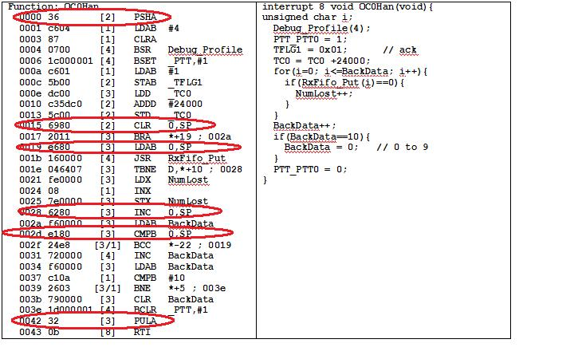

PTT_PTT0=1 takes 4 cycles.